Predictive Repetitive Control: Design, Implementation and Applications Using MATLAB®

Speakers: Professor Liuping Wang, RMIT University, Australia

Professor Eric Rogers, University of Southampton, UK

Dr Craig Buhr, MathWorks

Workshop Outline

Model Predictive Control (MPC) has a long history in the field of control engineering. It is one of the few areas that has received on-going interest from researchers in both the industrial and academic communities. Three major aspects of model predictive control make the design methodology attractive to both engineers and academics. The first aspect is the design formulation, which uses a completely multivariable system framework where the performance parameters of the multivariable control system are related to the engineering aspects of the system; hence, they can be understood and 'tuned' by engineers. The second aspect is the ability of method to handle both 'soft' constraints and hard constraints in a multivariable control framework. This is particularly attractive to industry where tight profit margins and limits on the process operation are inevitably present. The third aspect is the ability to perform process on-line optimization.

In the majority of applications, MPC is designed to follow constant reference signals and reject disturbances that have predominantly low frequency contents. However, these types of model predictive controllers are not adequate to provide the closed-loop performance required when the reference signals and the disturbances are complex and have periodic components. This has motivated the speakers to develop a new class of model predictive controllers that use the design framework of MPC while addressing the requirements of controlling systems with periodic components, which is called predictive repetitive controller.

Using experimentally validated applications, this half-day workshop will highlight the four steps involved in the design of a predictive-repetitive controller: (i) frequency response analysis to extract dominant periodic components of the reference or disturbance signals and re-construct the signals using frequency sampling filters; (ii) the design of predictive repetitive controllers by embedding the dominant periodic components; (iii) the design of constrained predictive repetitive controllers using quadratic programming algorithms; (iv) simulation and experimental validation of the predictive repetitive control system with constraints using MATLAB® and Simulink® as a platform.

The core material of this course, based on the books entitled ‘Model Predictive Control System Design and Implementation using MATLAB’ (Springer, 2009) and ‘PID and Predictive Control of Electrical Drives and Power Converters using MATLAB and Simulink’ (Wiley, 2015) by the first speaker, ‘Iterative Learning Control for Electrical Stimulation and Stroke Rehabilitation’ (Springer, 2013) and
‘Iterative Learning Control: Algorithms and Experimental Benchmarking’ (Wiley, 2014) by the second speaker, is suitable for engineers, students and researchers who wish to gain basic knowledge about predictive repetitive control, as well as understand how to perform real time simulation and implementation using MATLAB and Simulink tools. The lecture slides and MATLAB/Simulink programs used in the examples will be available to the participants.

Workshop Schedule

9:00-10:30: Design of Predictive Repetitive Control Systems
The essentials in tracking of complex reference signals and rejecting band-limited disturbance, frequency decomposition using frequency sampling filters, complementary sensitivity functions, sensitivity functions, embedding periodic components into design model, receding horizon control, predictive repetitive control systems without constraints, observer design.
10:30-10:45 Coffee Break
10: 45-11:45 Constrained Predictive Repetitive Controllers
Anti-windup mechanisms as non-optimal solutions, optimal solutions using quadratic programming algorithms.
11:45-12:30 Predictive Repetitive Control of Robots with Constraints
Modelling of one-dimensional robot and two-dimensional robot, predictive repetitive control of robots, simulation results and experimental results.

12:30 – 2:30 Workshop Lunch
Lunch with the speakers and developers from MathWorks

About the Speakers

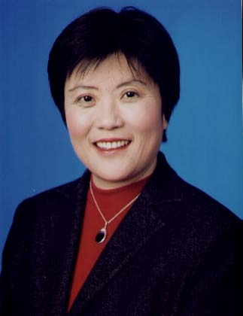
Professor Liuping Wang received her Ph.D degree in 1989 from the Department of Automatic Control and Systems Engineering, University of Sheffield, UK. Upon completion of her PhD degree, she worked in the Department of Chemical Engineering at the University of Toronto, Canada for eight years in the field of process control. From 1998 to 2002, she worked in the Center for Integrated Dynamics and Control, University of Newcastle, Australia. In February 2002, she joined the School of Electrical and Computer Engineering, RMIT University, Australia where she is a Professor of Control Engineering. She has authored and co-authored more than 190 scientific papers in the field of system identification, PID control, adaptive control, model predictive control, electrical drive control and control technology application to industrial processes. She co-authored a book with Professor Will Cluett entitled From Process Data to Process Control- Ideas for Process Identification and PID control (Taylor and Francis, 2000). She co-edited two books with Professor Hugues Garnier entitled ‘ Continuous time model identification from sampled data’ (Springer-Verlag, 2008) and ‘System identification, environmental modelling and control’ (Springer-Verlag, 2011) . Her book entitled ‘ Model Predictive Control Design and Implementation using MATLAB®’ was published by Springer-Verlag in 2009, and the second edition of this book is currently under preparation. She is the lead author of the book entilted ‘PID and predictive control of electrical drives and power converters using using MATLAB®’ published by Wiley in 2015. Dr Liuping Wang has successfully applied the predictive control technologies to food extruders, automotive brake-by-wire systems, magnetic bearing systems, electrical drives and power converters. Dr Liuping Wang is an associate editor of International Journal of Control, Journal of Process Control and IEEE Transactions on Control System Technologies, and a Fellow of Institute of Engineers Australia.
Eric Rogers is Professor of Control Systems Theory and Design in the School of Electronics and Computer Science, University of Southampton. His current research interests are in iterative learning and repetitive control theory and applications, flow control, algeraic/behavioral approaches to multidimensional systems and repetitive predictive control. In terms of applications, the Southampton group of which he is the senior academic have transferred iterative learning control algorithms to robotic-assisted upper limb stroke rehabilitation with supporting clinical trials and smart rotor based control of wind turbines. He is the editor-in-chief of the International Journal of Control and has served on the organising/international programme committees of many international conferences. He has also served as a consultant to many government and industrial organisations in the United Kingdom and elsewhere.

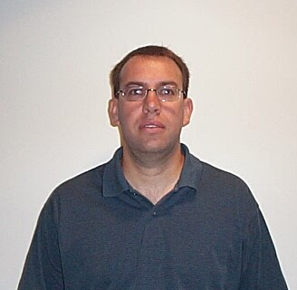
Dr Craig Buhr graduated from the School of Mechanical Engineering at Purdue University in 1993. He later received his M.S. and Ph.D. degrees from the School of Mechanical Engineering at Purdue University in 1996 and 2003, respectively. His research interests include dynamic system modeling and identification, linear systems and control theory. He joined the MathWorks as a Senior Developer for the Control System Toolbox in 2003 developing software tools to facilitate the design and analysis of control systems. He is currently the Senior Team Lead of the Control Design group.

